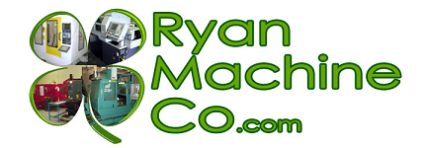

RYAN MACHINE COMPANY, INC.
2327 Bohannon Drive

Santa Clara, Ca. 95050
PH (408) 315 3497
pat@ryanmachineco.com
www.ryanmachineco.com

We are pleased to offer the following quality used machine tool:

2000 Mori Seiki SL-25E (Extended X travel)

GENERAL SPECIFICATIONS

Chuck Size: 10"
Max Diameter Bar Capacity: 2.5"
Spindle Motor: 20 HP AC
Spindle Speed: 35 - 3500 RPM
Spindle Bore: 3.15"
Spindle Nose: A2-6
Tools: 10
Rapid Traverse Rates (X / Z): 472 / 590 IPM
X-Axis Travel: 8.66"
Z-Axis Travel: 23.2"
Tailstock Taper: MT #3
Turret Index (Single Step / Full): 0.7 / 1.5 Seconds

Machine Dimensions (L x W x H): 112.6" x 63.4" x 74.6"
Machine Weight: 10,000 lbs.

Equipped with:

Mori MSC500 Control
10” Chuck
Tool Setter

In excellent condition. Only 9,100 cut hours.

